Program -01
Aim:- XOR operation.
#include<stdio.h>
#include<conio.h>
int main(){
char str[] ="hello world";
int len=0,i,j;
clrscr();
len=strlen(str);
for(i=0;i<len;i++){
str[i]= str[i]^0;
}
printf("%s",str );
getch();
}
OUTPUT:-

Program -02
Aim:- XOR operations,XOR+0,XOR+128.
#include<stdio.h>
#include<conio.h>
int main(){
char str[] ="hello world";
int len=0,i,j;
clrscr();
len=strlen(str);
for(i=0;i<len;i++){
str[i]= str[i]^0;
}
printf("%s",str );
getch();
}
OUTPUT:-
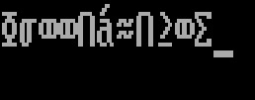

Program -03

Aim:- Ceaser cipher,hill cipher and substitution cipher.
a)Ceaser cipher.
#include<stdio.h>

int main()
{
char message[100], ch;
int i, key;

printf("Enter a message to decrypt: ");
gets(message);
printf("Enter key: ");
scanf("%d", &key);

for(i = 0; message[i] != '\0'; ++i){
ch = message[i];

if(ch >= 'a' && ch <= 'z'){
ch = ch - key;

if(ch < 'a'){
ch = ch + 'z' - 'a' + 1;
}

message[i] = ch;
}
else if(ch >= 'A' && ch <= 'Z'){
ch = ch - key;

if(ch < 'A'){
ch = ch + 'Z' - 'A' + 1;
}

message[i] = ch;
}
}

printf("Decrypted message: %s", message);

return 0;
}
Output:-

#include<stdio.h>

int main()
{
char message[100], ch;
int i, key;

printf("Enter a message to decrypt: ");
gets(message);
printf("Enter key: ");
scanf("%d", &key);

for(i = 0; message[i] != '\0'; ++i){
ch = message[i];

if(ch >= 'a' && ch <= 'z'){
ch = ch - key;

if(ch < 'a'){
ch = ch + 'z' - 'a' + 1;
}

message[i] = ch;
}
else if(ch >= 'A' && ch <= 'Z'){
ch = ch - key;

if(ch < 'A'){
ch = ch + 'Z' - 'A' + 1;
}

message[i] = ch;
}
}

printf("Decrypted message: %s", message);

return 0;
}
Output:-

b) hill cipher:-
import java.io.*;
import java.util.*;
import java.io.*;
class HillCipher {
static int[][] a = new int[3][3];
static int[][] b = new int[3][3];
static int[][] mes = new int[3][1];
static int[][] res = new int[3][1];
static BufferedReader br = new BufferedReader(new InputStreamReader(
System.in));
static Scanner sc = new Scanner(System.in);

public static void main(String[] args) throws IOException {
getKeys();
for (int i = 0; i < 3; i++)
for (int j = 0; j < 1; j++)
for (int k = 0; k < 3; k++) {
res[i][j] = res[i][j] + a[i][k] * mes[k][j];
}
System.out.print("\nEncrypted string is : ");
for (int i = 0; i < 3; i++) {
// Hill Cipher actual Encryption logic modulo 26
System.out.print((char) (res[i][0] % 26 + 97));
res[i][0] = res[i][0];
}
}
public static void getKeys() throws IOException {
System.out
.println("Enter 3x3 matrix for key (It should be inversible): ");
for (int i = 0; i < 3; i++)
for (int j = 0; j < 3; j++)
a[i][j] = sc.nextInt();
System.out.print("\nEnter a 3 letter string: ");
String msg = br.readLine();
for (int i = 0; i < 3; i++)
mes[i][0] = msg.charAt(i) - 97;
}
}
output:-
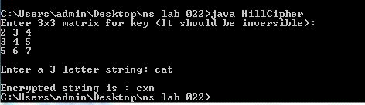

c)Substitution cipher:-

class SubstitutionCipher

{

public static void main(String args[]){
String pt = args[0];
String k = args[1];
char characters[] = pt.toCharArray();
int shift = Integer.parseInt(k);
int remainder = shift % 26;
for( int i=0; i < characters.length; i++)
{
if ((Character.isUpperCase(characters[i]))== true)
{
if((int)(characters[i]) + remainder >= 90)
{
characters[i] = (char)(characters[i]-(26-remainder));
}
else
{
characters[i] = (char)(characters[i]+remainder);
}
}
else if (Character.isLowerCase(characters[i])==true)
{
if ((int)(characters[i] + remainder) >= 122)
{
characters[i] = (char)(characters[i] - (26-remainder));
}
else
{
characters[i] = (char)(characters[i]+remainder);
}
}
}
for(int i =0; i< characters.length;i++)
System.out.println (characters[i]);
}

}
output:

Program -04
4. Java program for DES algorithm logic
AIM: Write a Java program to implement the DES algorithm logic.
PROGRAM:
import java.util.*;
import java.io.BufferedReader;
import java.io.InputStreamReader;
import java.security.spec.KeySpec;
import javax.crypto.Cipher;
import javax.crypto.SecretKey;
import javax.crypto.SecretKeyFactory;
import javax.crypto.spec.DESedeKeySpec;
import sun.misc.BASE64Decoder;
import sun.misc.BASE64Encoder;
public class DES {
private static final String UNICODE_FORMAT = "UTF8";
public static final String DESEDE_ENCRYPTION_SCHEME = "DESede";
privateKeySpecmyKeySpec;
privateSecretKeyFactorymySecretKeyFactory;
private Cipher cipher;
byte[] keyAsBytes;
private String myEncryptionKey;
private String myEncryptionScheme;
SecretKey key;
static BufferedReader br = new BufferedReader(new InputStreamReader(System.in));
public DES() throws Exception {
// TODO code application logic here
myEncryptionKey = "ThisIsSecretEncryptionKey";
myEncryptionScheme = DESEDE_ENCRYPTION_SCHEME;
keyAsBytes = myEncryptionKey.getBytes(UNICODE_FORMAT);
myKeySpec = new DESedeKeySpec(keyAsBytes);
mySecretKeyFactory = SecretKeyFactory.getInstance(myEncryptionScheme);
cipher = Cipher.getInstance(myEncryptionScheme);
key = mySecretKeyFactory.generateSecret(myKeySpec);
}
public String encrypt(String unencryptedString) {
String encryptedString = null;
try {
cipher.init(Cipher.ENCRYPT_MODE, key);
byte[] plainText = unencryptedString.getBytes(UNICODE_FORMAT);
byte[] encryptedText = cipher.doFinal(plainText);
BASE64Encoder base64encoder = new BASE64Encoder();
encryptedString = base64encoder.encode(encryptedText); }
catch (Exception e) {
e.printStackTrace(); }
returnencryptedString; }
public String decrypt(String encryptedString) {
String decryptedText=null;
try {
cipher.init(Cipher.DECRYPT_MODE, key);
BASE64Decoder base64decoder = new BASE64Decoder();
byte[] encryptedText = base64decoder.decodeBuffer(encryptedString);
byte[] plainText = cipher.doFinal(encryptedText);
decryptedText= bytes2String(plainText); }
catch (Exception e) {
e.printStackTrace(); }
returndecryptedText; }
private static String bytes2String(byte[] bytes) {
StringBufferstringBuffer = new StringBuffer();
for (int i = 0; i <bytes.length; i++) {
stringBuffer.append((char) bytes[i]); }
returnstringBuffer.toString(); }
public static void main(String args []) throws Exception {
System.out.print("Enter the string: ");
DES myEncryptor= new DES();
String stringToEncrypt = br.readLine();
String encrypted = myEncryptor.encrypt(stringToEncrypt);
String decrypted = myEncryptor.decrypt(encrypted);
System.out.println("\nString To Encrypt: " +stringToEncrypt);
System.out.println("\nEncrypted Value : " +encrypted);
System.out.println("\nDecrypted Value : " +decrypted);
System.out.println("");
}
}
output:

Program -05

5. Program to implement Blowfish algorithm logic
AIM: Write a C/JAVA program to implement the Blowfish algorithm logic.

PROGRAM:
import java.io.*;
import java.io.FileInputStream;
import java.io.FileOutputStream;
import java.security.Key;
import javax.crypto.Cipher;
import javax.crypto.CipherOutputStream;
import javax.crypto.KeyGenerator;
import sun.misc.BASE64Encoder;
public class BlowFish {
public static void main(String[] args) throws Exception {
// TODO code application logic here
KeyGeneratorkeyGenerator = KeyGenerator.getInstance("Blowfish");
keyGenerator.init(128);
Key secretKey = keyGenerator.generateKey();
Cipher cipherOut = Cipher.getInstance("Blowfish/CFB/NoPadding");
cipherOut.init(Cipher.ENCRYPT_MODE, secretKey);
BASE64Encoder encoder = new BASE64Encoder();
byte iv[] = cipherOut.getIV();
if (iv != null) {
System.out.println("Initialization Vector of the Cipher: " + encoder.encode(iv)); }
FileInputStream fin = new FileInputStream("inputFile.txt");
FileOutputStreamfout = new FileOutputStream("outputFile.txt");
CipherOutputStreamcout = new CipherOutputStream(fout, cipherOut);
int input = 0;
while ((input = fin.read()) != -1) {
cout.write(input); }
fin.close(); cout.close(); } }

Program -06

06. Diffie-Hellman

AIM: Implement the Diffie-Hellman Key Exchange mechanism using HTML and
JavaScript. Consider the end user as one of the parties (Alice) and the JavaScript
application as other party (bob).

PROGRAM:
import java.math.BigInteger;
import java.security.KeyFactory;
import java.security.KeyPair;
import java.security.KeyPairGenerator;
import java.security.SecureRandom;
import javax.crypto.spec.DHParameterSpec;
import javax.crypto.spec.DHPublicKeySpec;
public class DiffeHellman {
public final static int pValue = 47;
public final static int gValue = 71;
public final static int XaValue = 9;
public final static int XbValue = 14;
public static void main(String[] args) throws Exception {
// TODO code application logic here
BigInteger p = new BigInteger(Integer.toString(pValue));
BigInteger g = new BigInteger(Integer.toString(gValue));
BigIntegerXa = new BigInteger(Integer.toString(XaValue));
BigIntegerXb = new BigInteger(Integer.toString(XbValue));
createKey();
intbitLength = 512; // 512 bits
SecureRandomrnd = new SecureRandom();
p = BigInteger.probablePrime(bitLength, rnd);
g = BigInteger.probablePrime(bitLength, rnd);
createSpecificKey(p, g);
}
public static void createKey() throws Exception {
KeyPairGeneratorkpg = KeyPairGenerator.getInstance("DiffieHellman");
kpg.initialize(512);
KeyPairkp = kpg.generateKeyPair();
KeyFactorykfactory = KeyFactory.getInstance("DiffieHellman");
DHPublicKeySpeckspec = (DHPublicKeySpec) kfactory.getKeySpec(kp.getPublic(),
DHPublicKeySpec.class);
System.out.println("Public key is: " +kspec);
}
public static void createSpecificKey(BigInteger p, BigInteger g) throws Exception {
KeyPairGeneratorkpg = KeyPairGenerator.getInstance("DiffieHellman");
DHParameterSpecparam = new DHParameterSpec(p, g);
kpg.initialize(param);
KeyPairkp = kpg.generateKeyPair();
KeyFactorykfactory = KeyFactory.getInstance("DiffieHellman");
DHPublicKeySpeckspec = (DHPublicKeySpec) kfactory.getKeySpec(kp.getPublic(),
DHPublicKeySpec.class);
System.out.println("\nPublic key is : " +kspec);
}
}
OUTPUT:

Program -07

Aim:- GCD
#include <stdio.h>
int main()
{
int n1, n2, i, gcd;

printf("Enter two integers: ");
scanf("%d %d", &n1, &n2);

for(i=1; i <= n1 && i <= n2; ++i)
{
// Checks if i is factor of both integers
if(n1%i==0 && n2%i==0)
gcd = i;
}

printf("G.C.D of %d and %d is %d", n1, n2, gcd);

return 0;
}
OUTPUT:-
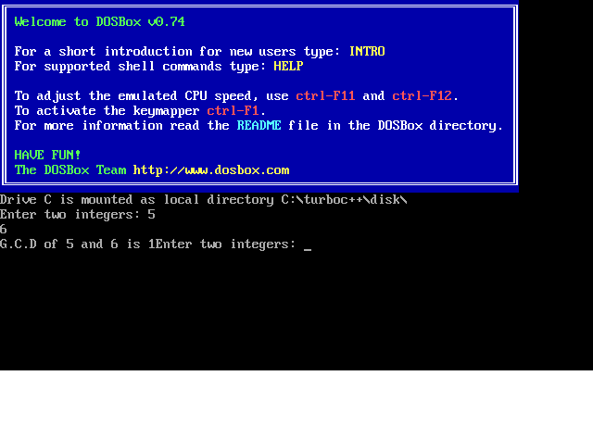

Program -08

Aim:- Rabin miller.
#include <stdio.h>

#include <string.h>

#include <stdlib.h>

/*

* calculates (a * b) % c taking into account that a * b might overflow

*/

long long mulmod(long long a, long long b, long long mod)

{

long long x = 0,y = a % mod;

while (b > 0)

{

if (b % 2 == 1)

{

x = (x + y) % mod;

}

y = (y * 2) % mod;

b /= 2;

}

return x % mod;

}

/*

* modular exponentiation

*/

long long modulo(long long base, long long exponent, long long mod)

{

long long x = 1;

long long y = base;

while (exponent > 0)

{

if (exponent % 2 == 1)

x = (x * y) % mod;

y = (y * y) % mod;

exponent = exponent / 2;

}

return x % mod;

}

/*

* Miller-Rabin Primality test, iteration signifies the accuracy

*/

int Miller(long long p,int iteration)

{

int i;

long long s;

if (p < 2)

{

return 0;

}

if (p != 2 && p % 2==0)

{

return 0;

}

s = p - 1;

while (s % 2 == 0)

{

s /= 2;

}

for (i = 0; i < iteration; i++)

{

long long a = rand() % (p - 1) + 1, temp = s;

long long mod = modulo(a, temp, p);

while (temp != p - 1 && mod != 1 && mod != p - 1)

{

mod = mulmod(mod, mod, p);

temp *= 2;

}

if (mod != p - 1 && temp % 2 == 0)

{

return 0;

}

}

return 1;

}

//Main

int main()

{

int iteration = 5;

long long num;

printf("Enter integer to test primality: ");

scanf("%lld", &num);

if ( Miller( num, iteration))

printf("\n%lld is prime\n", num);

else

printf("\n%lld is not prime\n", num);

return 0;

}
OUTPUT:-
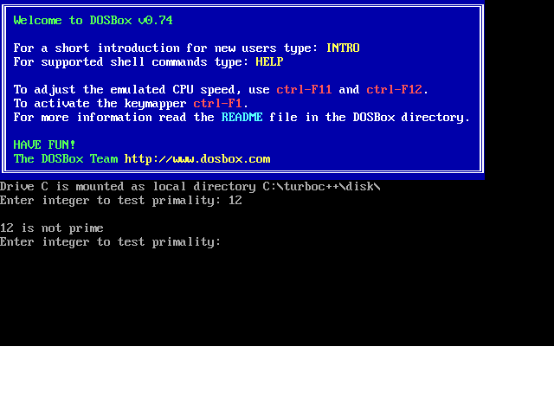

Program -09

Aim:- SHA-1 Algorithm.
import java.security.*;
public class SHA1 {

public static void main(String[] a) {
try {
MessageDigest md = MessageDigest.getInstance("SHA1");
String input = a[0];
md.update(input.getBytes());
byte[] output = md.digest();
System.out.println();
System.out.println(input+ " = " +bytesToHex(output));
input = a[1];
md.update(input.getBytes());
output = md.digest();
System.out.println();
System.out.println(input+ " = " +bytesToHex(output));
System.out.println(""); }
catch (Exception e) {
System.out.println("Exception: " +e);
}
}
public static String bytesToHex(byte[] b) {
char hexDigit[] = {'0', '1', '2', '3', '4', '5', '6', '7', '8', '9', 'A', 'B', 'C', 'D', 'E', 'F'};
StringBuffer buf = new StringBuffer();
for (int j=0; j<b.length; j++) {
buf.append(hexDigit[(b[j] >> 4) & 0x0f]);
buf.append(hexDigit[b[j] & 0x0f]); }
return buf.toString(); }
}

OUTPUT:-
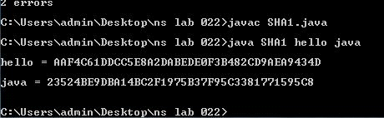

Program -10
Aim:- RSA Algorithm.

import java.math.BigInteger;
import java.security.SecureRandom;

class Rsa {
private final static BigInteger one = new BigInteger("1");
private final static SecureRandom random = new SecureRandom();

private BigInteger privateKey;
private BigInteger publicKey;
private BigInteger modulus;

Rsa(int N) {
BigInteger p = BigInteger.probablePrime(N/2, random);
BigInteger q = BigInteger.probablePrime(N/2, random);
BigInteger phi = (p.subtract(one)).multiply(q.subtract(one));
modulus = p.multiply(q);
publicKey = new BigInteger("65537");
privateKey = publicKey.modInverse(phi);
}

BigInteger encrypt(BigInteger message) {
return message.modPow(publicKey, modulus);
}

BigInteger decrypt(BigInteger encrypted) {
return encrypted.modPow(privateKey, modulus);
}

public String toString() {
String s = "";
s += "public = " + publicKey + "\n";
s += "private = " + privateKey + "\n";
s += "modulus = " + modulus;
return s;
}

public static void main(String[] args) {
int N = Integer.parseInt(args[0]);
Rsa key = new Rsa(N);
System.out.println(key);
BigInteger message = new BigInteger(N-1, random);
BigInteger encrypt = key.encrypt(message);
BigInteger decrypt = key.decrypt(encrypt);
System.out.println("message = " + message);
System.out.println("encrypted = " + encrypt);
System.out.println("decrypted = " + decrypt);
}
}
OUTPUT:

